

Topic test 1
Name: __________________________________

Chapter 2: Complex numbers and
De Moivre’s theorem

- Time allowed: 45 minutes
- CAS calculators may be used.
- Part A: 5 multiple-choice questions (5 marks).
- Part B: 6 short-answer questions (12 marks).
- Part C: 2 analysis questions (7 marks).
Part A
Multiple-choice questions
5 multiple-choice questions
1 mark each: 5 marks
Circle the correct answer.
1 The value of 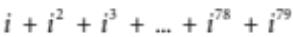 is
A i
B 1
C −1
D −i
E 0
[1 mark]
2 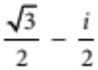 is equal to
A 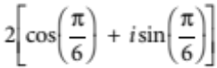
B 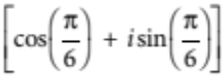
C 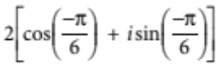
D 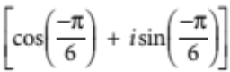
E 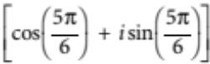
[1 mark]
3 In the diagram, the complex numbers z, w, u and v are shown.
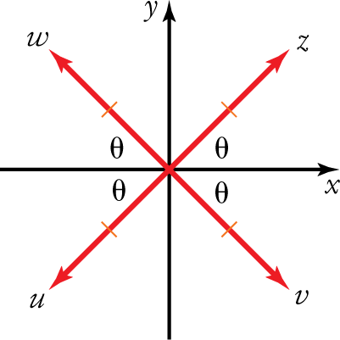
Which of the following is true?
A 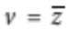
B 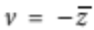
C 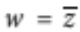
D 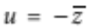
E
[1 mark]
4 The complex number 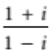 is equivalent to
A
B 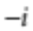
C 1
D −1
E 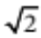
[1 mark]
5 The complex number 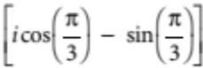 in mod-arg form is:
A 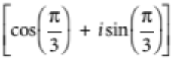
B 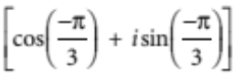
C 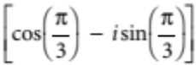
D 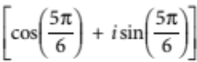
E 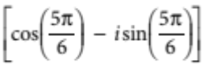
[1 mark]

Part B
Short-answer questions
6 short-answer questions
12 marks
Show your working where appropriate.
1 Simplify 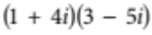.
[2 marks]
2 Express 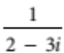 in the form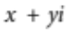.
[2 marks]
3 Calculate if 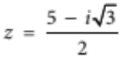.
[2 marks]
4 Use De Moivre’s theorem to simplify 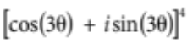.
[1 mark]
5 Simplify 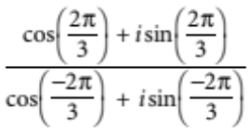.
[2 marks]
6 Express 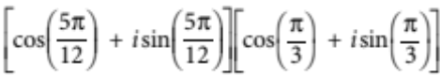 in the form .
[3 marks]
Part C
Analysis questions
2 analysis questions
7 marks
Show your working where appropriate.
1 Show that 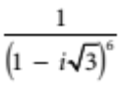 is always real.
[4 marks]
2 Prove for complex z that 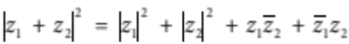.
[3 marks]
[Total marks: 24]

Answers
Part A – Multiple-choice questions [1 mark each]
1
 C [1 mark]
2 is the reflection of z over the x-axis.
 A [1 mark]
3 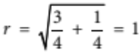, 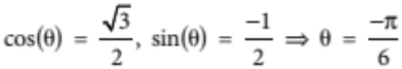
 D [1 mark]
4 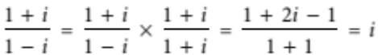
 A [1 mark]
5 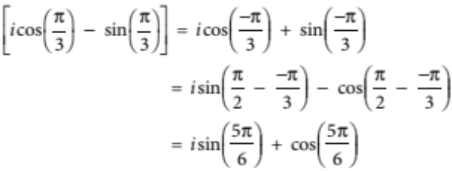
 D [1 mark]
Part B – Short-answer questions
1 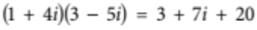 [1 mark]
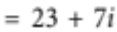 [1 mark]
[2 marks altogether]
2 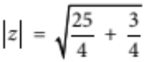 [1 mark]
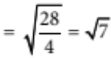 [1 mark]
[2 marks altogether]
3 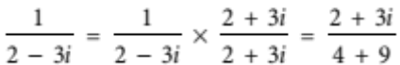 [1 mark]
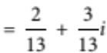 [1 mark]
[2 marks altogether]
4 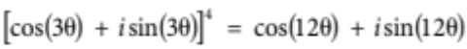 [1 mark]

5
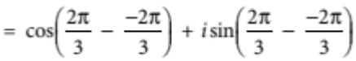 [1 mark]
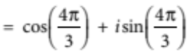
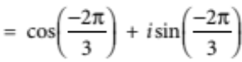 [1 mark]
[2 marks altogether]
6 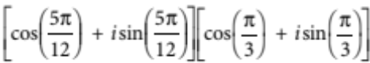
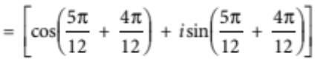 [1 mark]
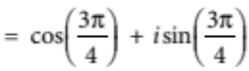 [1 mark]
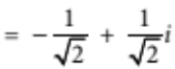 [1 mark]
[3 marks altogether]
Part C – Analysis questions
1 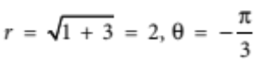 [1 mark]
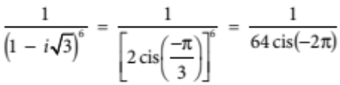 [1 mark]
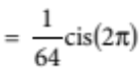 [1 mark]
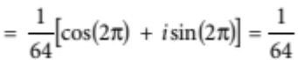, which is real. [1 mark]
[4 marks altogether]

2 Let z be a complex number.
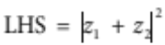
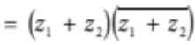using the identity 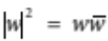 [1 mark]
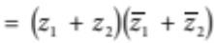 [1 mark]
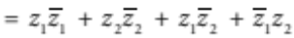
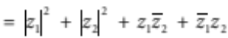
= RHS using the identity QED [1 mark]
[3 marks altogether]

